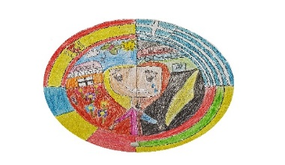

ONLINE ESL INTERDISCIPLINARY GAMES

ERASMUS + KA2 – 2018-1-RO01-KA229-049395

“ STOP ESL! START INTERDISCIPLINARY EDUCATION FOR FUTURE!”

ȘCOALA GIMNAZIALĂ SFȂNTUL ANDREI,BRĂILA, ROMANIA
2o DIMOTIKO SXOLEIO DRAPETSONAS, DRAPETSONA, GREECE
Klaipedos Tauralaukio progimnazija, KLAIPEDA, LITHUANIA

IES MADINA MAYURQA, PALMA DE MALLORCA, SPAIN

Editor's Note

Early School Leaving (ESL) is a major problem in many European Union (EU) countries and a multitude of factors are taken into account in the effort to limit it. School teachers can contribute in this direction, wielding the mean they can use best: education. That is why we planned, implemented, and propose a number of online games, which are freely available to all colleagues interested in tackling this important issue.
The proposed games can be adapted easily to satisfy the peculiarities that render each school different. They have been grouped together in thematic blocks according to their subject matter and/or the cognitive areas covered (basic skills, social and life skills, foreign language learning, and technology). All online games are the result of cooperation among the participating teachers from partner schools in the project and have been tried in class. The common denominator that binds them together is the use of cooperative learning which aims to foster a sense of belonging in students so that the chances of dropping out of school can be reduced.
Our reasoning is based on the supposition that children love what they can be good at. As a result, teaching should aim beyond the pursuit of knowledge and offer all students the opportunity of experiencing success. This could act as yet another motive for them to stay in school and even view it as second home.
CONTENT

A. e-Learning course – for teachers: How to use open sources in classes by ROTARU CĂTĂLINA

1. Learning apps
2. Kahoot
3. Edmodo
4. QR code
5. Pic Collage
B. GREECE ONLINE GAMES
C . LITHUANIA ONLINE GAMES
D. SPAIN ONLINE GAMES
E. ROMANIA ONLINE GAMES

- LearningApps – LearningApps.org - interaktive und multimediale Lernbausteine - https://learningapps.org/

LearningApps.org is a Web 2.0 application, to support learning and teaching processes with small interactive modules. Those modules can be used directly in learning materials, but also for self studying. The aim is to collect reusable building blocks and make them available to everyone. Blocks (called Apps) include no specific framework or a specific learning scenario. The blocks are therefore not suitable as complete lessons or tasks, instead they must be embedded in an appropriate teaching scenario.

LearningApps.org Terms of Use and Privacy Policy
LearningApps.org is a non-commercial platform to support teaching and learning processes and is developed and maintained by the non-profit association Verein LearningApps interaktive Bausteine. The use of LearningApps.org and any content created using our authoring tools is free for educational purposes. They reserve the right to restrict or prohibit the use of LearningApps outside the educational context in the event of excessive use. LearningApps.org treats personal data confidentially and does not pass on any personal data to third parties.

Copyrights and misuse
The respective authors are responsible for the contents of the learning modules created and published with LearningApps.org. LearningApps.org may only be used for the creation and publication of content if no rights (e.g. copyrights) of third parties are violated.
The operator of this website can not able to check the legality of content created and published by third parties on LearningApps.org before it is published. LearningApps.org therefore assumes no responsibility for the respective contents of individual learning modules. If you find inappropriate content that is in any way illegal, defamatory, sexually harassing, copyright infringing, etc., please report this to the operator to remove the post if it is necessary.

Usage statistics
You can visit this website and use existing learning modules without having to provide any personal information. Access data (e.g. IP address, date and time of access, name of the file accessed) is only collected by the operator for the creation of anonymous usage statistics via Google Analytics as service provider. You can choose whether or not your use of LearningApps.org should be collected by Google Analytics for usage statistics: Google Analytics enabled / Google Analytics disabled

User account
Creating, saving and managing your own learning modules requires the use of your own user account. By entering personal data in your user account you agree to the publication of this data on LearningApps.org.
Authors of learning modules can view the use of their created content in anonymous statistics. You can delete your account at any time in your user settings. If you delete your account, all learning modules you have created are also deleted.

Student account
Teachers can create special student accounts for students or convert existing accounts into student accounts via a class invitation. Student accounts are managed by the teacher. The teacher has insight into the activities and the learning modules created by his students. Teachers can revise the learning modules created by student accounts and make them available to an entire class. If student accounts are managed by several teachers at the same time, all teachers have the same authority.

Private and public learning modules
All learning modules created on LearningApps.org are private by default and cannot be accessed by other users of the platform (except teachers on student accounts). All private learning modules have cryptic web links that are not accessed by search engines or LearningApps.org. The author of a learning module can communicate the cryptic web link or use the embed code to make the app available to a specific audience.
If desired, the author of a learning module can publish it on LearningApps.org. By publishing learning modules on LearningApps.org, authors agree that other users can freely use, copy and adapt their learning modules without having to refer to authorship. LearningApps.org alone decides whether learning modules are displayed in the public catalog or not.
When learning modules are used, information on the call and processing status is entered and saved. LearningApps.org does not store personal data such as individual entries or solutions.

No warranty
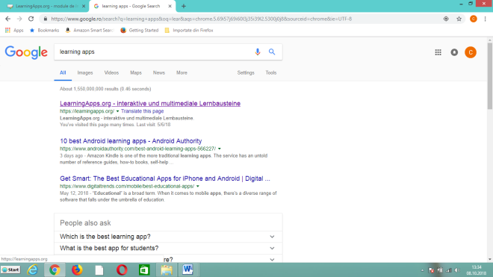
The services of LearningApps.org are provided without warranty of any kind. No guarantees are given for the availability, reliability, completeness or security of the service. Any liability is fully rejected.
Applicable law and place of jurisdiction
The declarations listed here are subject to Swiss law. The exclusive place of jurisdiction is Däniken, Switzerland.
Access - Google - LearningApps.org - interaktive und multimediale Lernbausteine.

Login – create an username and a password
Create App: You find different types of Apps

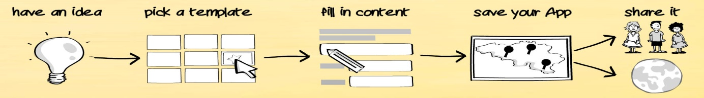

For example : Matching Pairs – game
Acces: Matching pairs icon
Acces: Create new app
Write a title: ........................................

Task description: Provide a task description for this App which is shown on start up. Otherwise leave it blank.
Pairs: Enter the two media which belong together. They can be a mix of text, images, audio or video.
+ Add another element – to add another pair, and so on you can put how many pairs you like
Additional, but wrong elements: You can add up to 3 additional elements that will be displayed but do not belong to the solution.
Make matching pairs disappear: Matching pairs will be automatically checked and then disappear. Without this option you can keep pairing until you check the solution manually. Matching pairs will not disappear.
Feedback: Provide a feedback text which will be displayed when the solution is found.

Help: Provide some hints how to solve the App. They can be viewed by the user via a small icon in the upper left corner. Otherwise leave it blank.
Do not forget: finish editing and show preview
You can change any time or to complete the game with other pairs

For example : Word Grid
Acces: Word grid icon
Acces: Create new app
Write a title: ........................................

Task description: Provide a task description for this App which is shown on start up. Otherwise leave it blank.
Background image: Select a background image for the crossword if you like.
You can select an image from your computer or from Internet
Words: Specify here the searched words.
Add another element – for another word
You can put how many words you want
Important – use Caps letters
Show the searched words: You can choose to show the words right from the beginning, making the exercise easier.
Feedback: Provide a feedback text which will be displayed when the solution is found.

Help: Provide some hints how to solve the App. They can be viewed by the user via a small icon in the upper left corner. Otherwise leave it blank.
Do not forget: finish editing and show preview
You can change any time or to complete the game with other words.
Advantages : all the games have a QR-code and a link to share

- Kahoot!
Kahoot! is a game-based learning platform, used as educational technology in schools and other educational institutions. The company was launched in August 2013 in Norway. Its learning games, "kahoots", are multiple-choice quizzes that allow user generation and can be accessed via web browser.
Kahoot can be used to review students' knowledge, for formative assessment, or as a break from traditional classroom activities.
Kahoot was designed for social learning, with learners gathered around a common screen such as an interactive whiteboard, projector or a computer monitor. The site can also be used through screen-sharing tools such as Skype. The game design is such that the players are required to frequently look up from their devices. The gameplay is simple; all players use a device to answer questions created by a teacher, business leader, or other person. These questions can be changed to award points. Points then show up on the leaderboard after each question.
Kahoot can be played through different web browsers and mobile devices through its web interface.
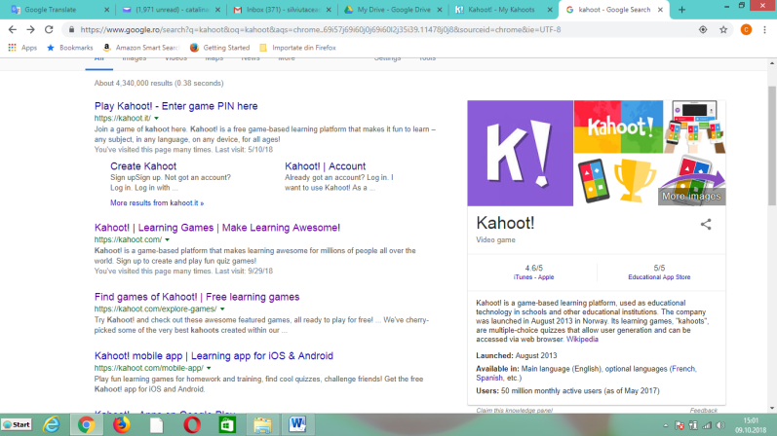
In September 2017, Kahoot launched a mobile application for homework.
In May 2017, YouTube channel GTLive played a game on their live stream with over 10,000 players.

Acces Google - Kahoot

Create an account – username and passoword
Create kahoot - can create 4 types of games:
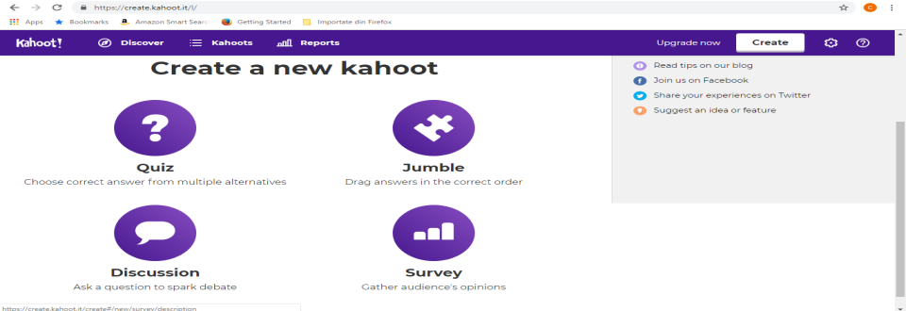

Choose – Quiz
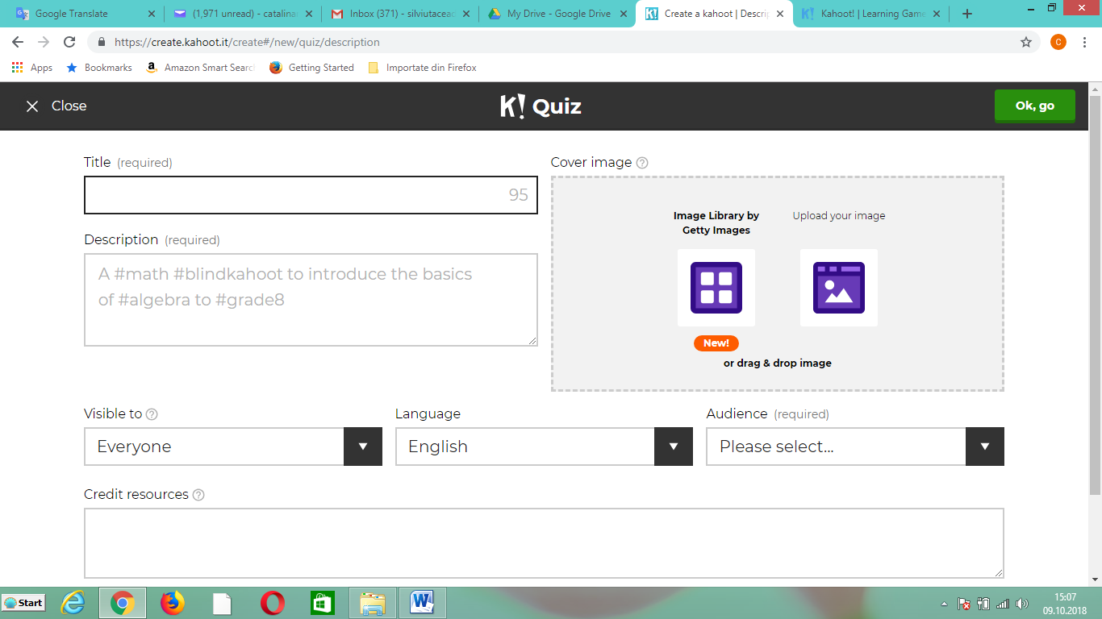
Fill the title, a short description, visible, language, audience, credit resources (it is not necessary) a link with a video (if you find something interesting), you can upload an image from your PC, or from Internet
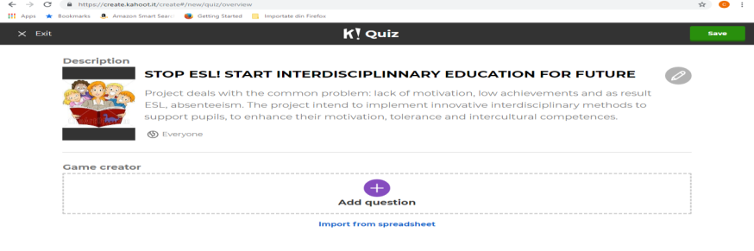
Ok, go

Add question
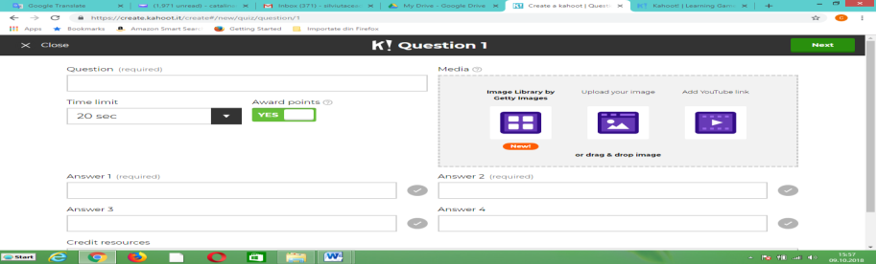

Type the question 1 correct answer 3 incorrect
You can change time limit
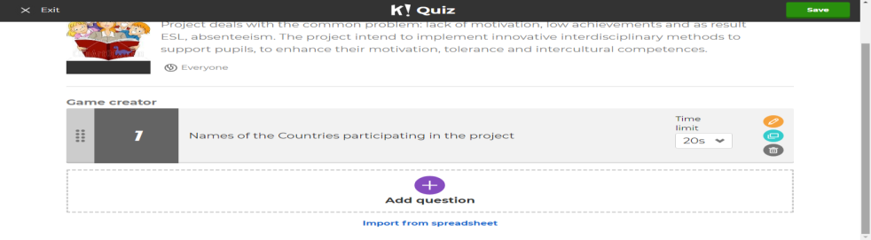
Next

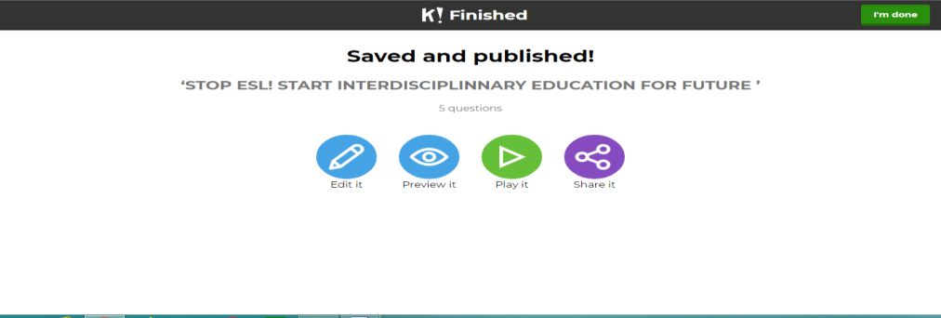
Add new question ....

After you finish – Save

I'm done
After that you can change, or add new questions – Edit it
Play it
Or Share it – it is a link where you find the quizz - as a theme for your students
Advantage: Students are engaged
At the reports you have an evaluation of all played games and you can download them in your PC / in Google drive or you can print it:
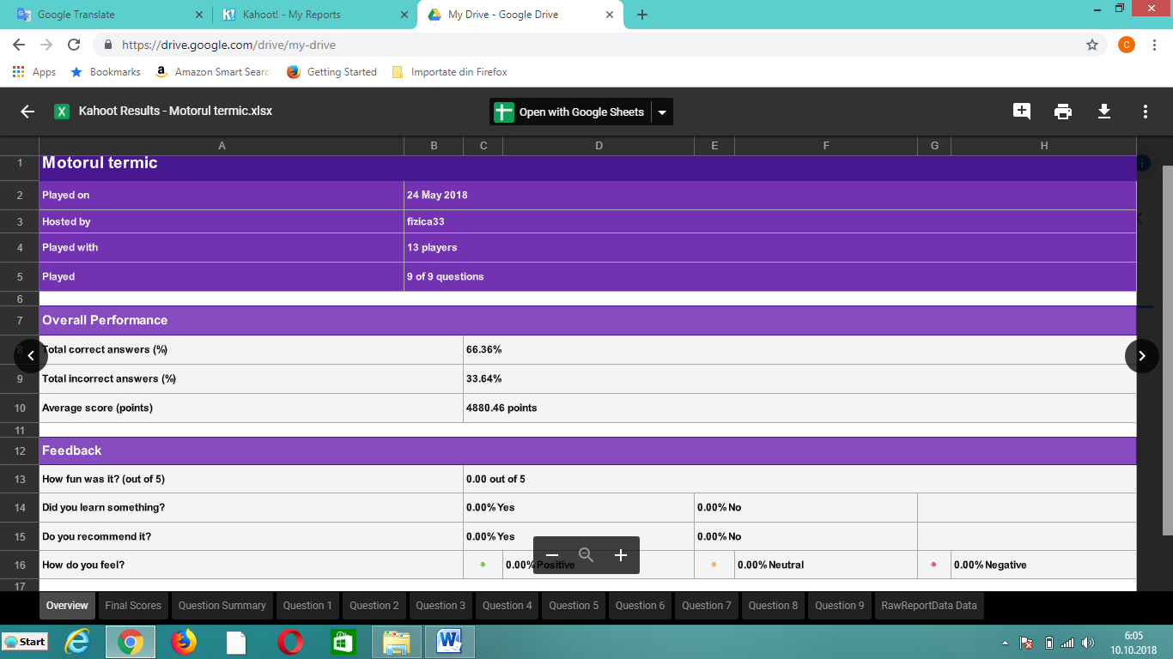
General

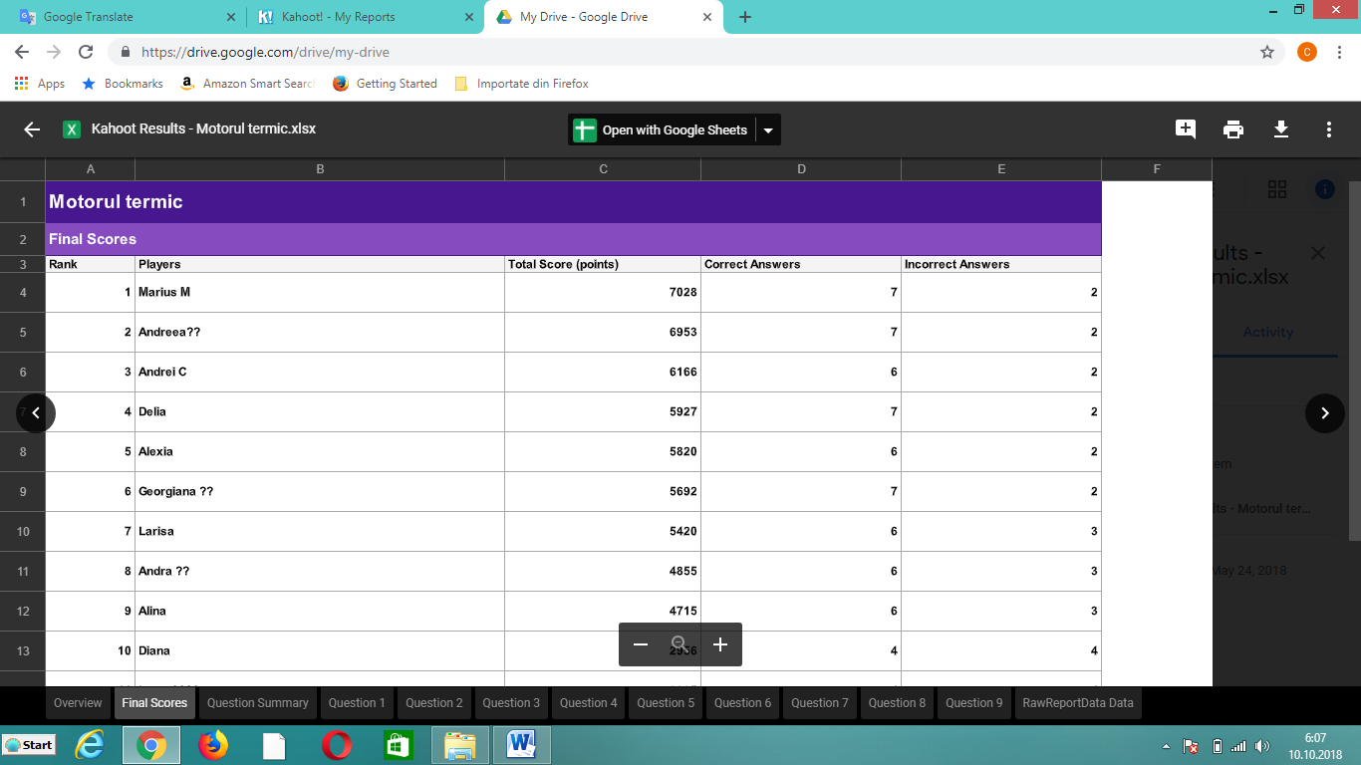
for each players – so you can evaluate and marks each students in a few minutes

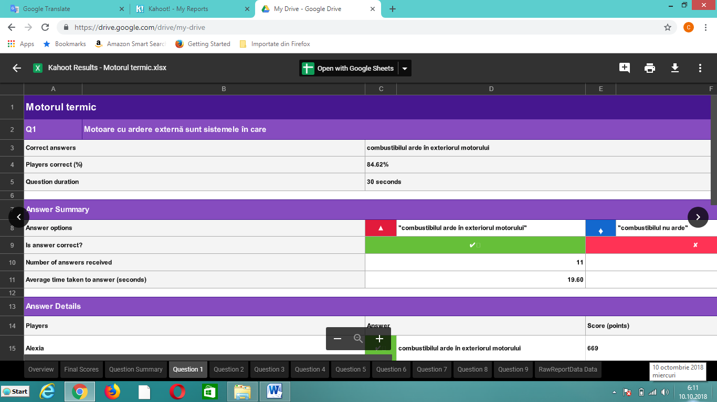
for each question – general report and each student answer

- EDMODO
Edmodo is an educational technology company offering a communication, collaboration, and coaching platform to schools and teachers. The Edmodo network enables teachers to share content, distribute quizzes, assignments, and manage communication with students, colleagues, and parents. Edmodo is very teacher-centric in their design and philosophy: students and parents can only join Edmodo if invited to do so by a teacher. Teachers and students spend large amounts of time on the platform, both in and out of the classroom.
Acces Google - Edmodo
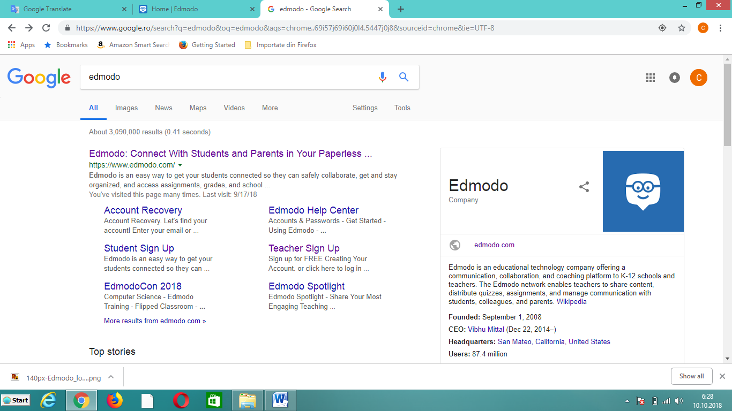
Create an account – username and passoword
Create classes – for each classes you will have a code
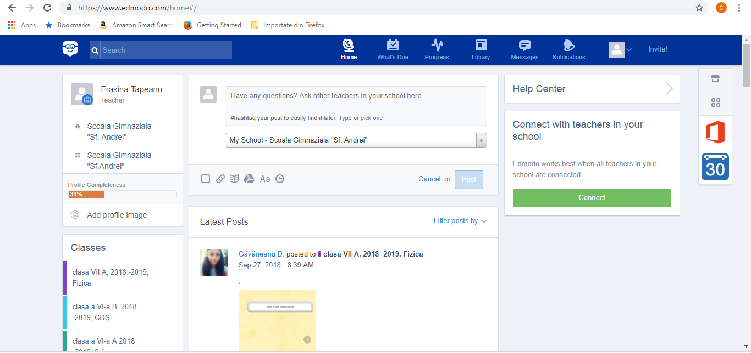
Pupils can connect as student and with the share code they can access the class.

Phone Apps – using your phone
- QR code reader
Magazin Play - In the query bar, type QR code reader: install
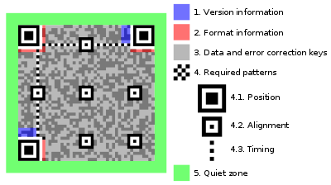
QR code reader
(abbreviated from Quick Response Code) is the trademark for a type of matrix barcode (or two-dimensional barcode) first designed in 1994 for the automotive industry in Japan. A barcode is a machine-readable optical label that contains information about the item to which it is attached. A QR code uses four standardized encoding modes (numeric, alphanumeric, byte/binary) to store data efficiently; extensions may also be used.
The Quick Response (QR code) system became popular outside the automotive industry due to its fast readability and greater storage capacity compared to standard UPC barcodes. Applications include product tracking, item identification, time tracking, document management, general marketing, games, quizziz.
A QR code consists of black squares arranged in a square grid on a white background, which can be read by an imaging device such as a camera, and processed using Reed–Solomon error correction until the image can be appropriately interpreted. The required data is then extracted from patterns that are present in both horizontal and vertical components of the image.
QR codes have become common in consumer advertising and in schools. Typically, a smartphone is used as a QR code scanner, displaying the code and converting it to some useful form (such as a standard URL for a website, a quizz, a question thereby obviating the need for a user to type it into a web browser). QR code has become a focus strategy, since it provides a way to access a an information more quickly than by manually entering a URL.
- Pic Collage
It is an apps - the best photo collage maker & free photo editor, that helps you to combine many photos into one layouts. And lets you make picture collage & Instacollage. Use the pic collage app to create photo collage with sticker, effects, text, filter and more, then share them to your friends via Messenger, Instagram, Facebook like a poster:
Import photos from your Pictures folder and web image search
- Simple touch gestures to rotate, resize, flick to delete
- Double-tap a photo to edit with Lumia photo effects, clip photos, adjust borders, copy/paste images, and "flip" stickers.
- Draw anything you want on your collage using Ink!
- Tap on the lower-left Frame icon, and swipe to select a frame to make an instant collage!
- Clip photos by outlining the area you want with your finger
- Lots of seasonal backgrounds and stickers to decorate your collages with!
- Beautiful and seasonal templates to choose from
- Share your creations

Bibliography
LearningApps.org - interaktive und multimediale Lernbausteine - https://learningapps.org/
https://learningapps.org/rechtliches.php
"Kahoot! as Formative Assessment - Center for Instructional Technology". Center for Instructional Technology. 2015-07-02. Retrieved 2017-08-09.
"Why Kahoot is one of my favourite classroom tools — Tomorrow's Learners". Retrieved 2017-08-09.
https://en.wikipedia.org/wiki/Edmodo
"Edmodo, Microblogging Platform for Educators, Merges with Revolution Learning's Fusion Project". PR Newswire. Feb 10, 2010.
"Edmodo Free Microblogging Site for Educators". Open Education. Sep 20, 2008.
"QR Code features". Denso-Wave. Archived from the original on 2013-01-29. Retrieved 3 October 2011.
"QR Code Essentials". Denso ADC. 2011. Archived from the original on 12 May 2013. Retrieved 12 March 2013.
Borko Furht (2011). Handbook of Augmented Reality. Springer. p. 341. ISBN 9781461400646. Archived from the original on 21 December 2016.
Joe Waters. "How to Use the Top QR Code Generators". Dummies.com. Archivedfrom the original on 11 September 2017. Retrieved 5 June 2017.
"QR Code—About 2D Code". Denso-Wave. Archived from the original on 5 June 2016. Retrieved 27 May 2016.
"QR Code Standardization". QR Code.com. Denso-Wave. Archived from the original on 10 May 2016. Retrieved 23 May 2016.

Pic collage https://www.microsoft.com/en-us/p/pic-collage/9nblggh34kdv?activetab=pivot%3aoverviewtab
B. GREECE ONLINE GAMES
2o DIMOTIKO SXOLEIO DRAPETSONAS
ART
https://create.kahoot.it/share/art/0c31ca51-00d0-4dca-bb79-1f36cfb68865

WISE GUYS!
https://create.kahoot.it/share/wise-guys/878120ab-5b1d-4255-8e31-72b69f88be89

At the supermarket
https://create.kahoot.it/share/at-the-supermarket/e4d5e695-5507-4861-b16a-1e70466d1d13

C. LITHUANIA ONLINE GAMES
Klaipedos Tauralaukio progimnazija

https://quizizz.com/admin/quiz/5cc9d97225773c001af10719

https://scratch.mit.edu/projects/96971107/

https://scratch.mit.edu/projects/98340481/

https://scratch.mit.edu/projects/253288990/

D. SPAIN ONLINE GAMES
IES MADINA MAYURQA
https://create.kahoot.it/details/the-sobrassada/c3faf8b6-ea45-475f-be87-ae98539b63c5

https://play.kahoot.it/#/k/75fe9042-117d-468d-b20b-0d1da6275e26

https://play.kahoot.it/#/k/f6907ce7-77d2-4606-a0a0-2051ea8dabb2

https://play.kahoot.it/#/k/c2436cee-fd17-450b-a653-0b0411ee8497

E. ROMANIA ONLINE GAMES

SCOALA GIMNAZIALA SFANTUL ANDREI

BIOLOGY-ICT/ARTS
- https://quizizz.com/admin/quiz/5bc7a72028a3f6001b8884f2

- https://play.kahoot.it/#/k/3e02e60a-3b0d-47d7-9242-e76be0b86d70

- https://b.socrative.com/teacher/#import-quiz/36516007

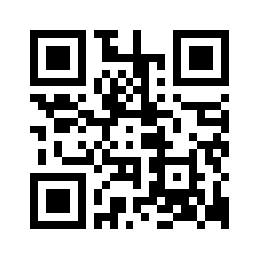  QR - code 1  5 puncte | QR - code 2  5 puncte
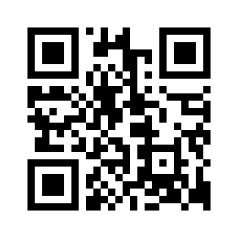  QR – code 3  5 puncte | 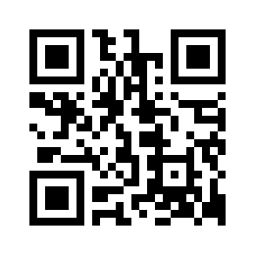  QR – code 4  5 puncte
QR – code 5  5 puncte | 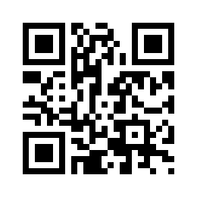  QR – code 6  5 puncte
QR - code 7  5 puncte | QR - code 8  5 puncte
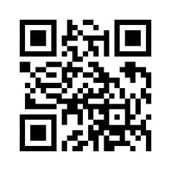  QR – code 9  5 puncte | 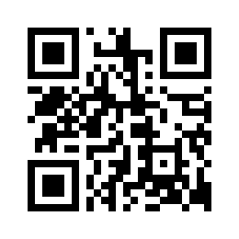  QR – code 10  5 puncte
QR – code 11  5 puncte | QR – code 12  10 puncte
LEARNINGAPPS.1  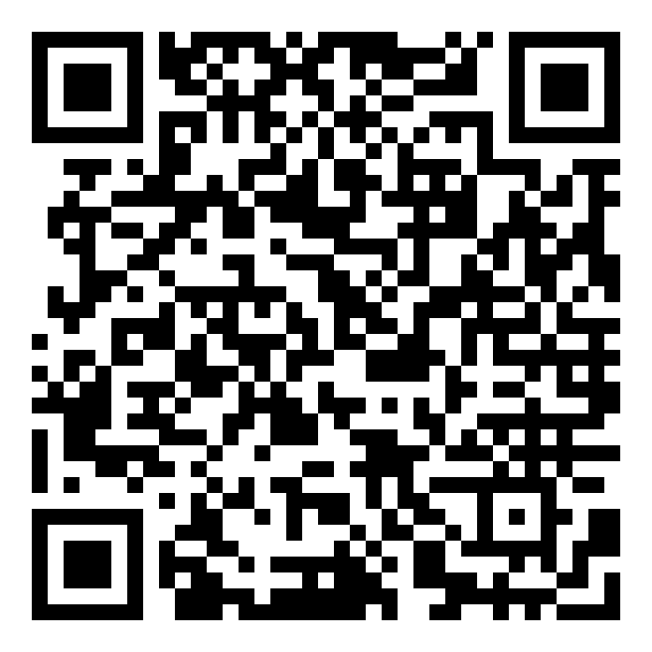  ‘  10 puncte | LEARNINGAPPS.2  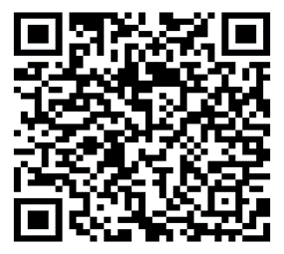  10 puncte
LEARNINGAPPS 4  10 puncte | LEARNINGAPPS.3  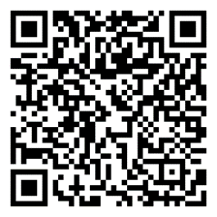  10 puncte

RELIGIOUS EDUCATION- CAREER COUNSELING

- https://play.kahoot.it/#/k/7c5576d3-0b9f-4615-9097-87e4702b50b1

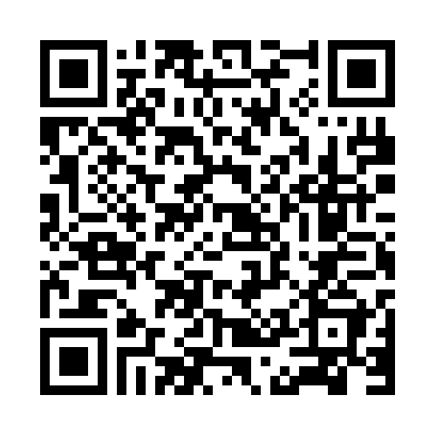
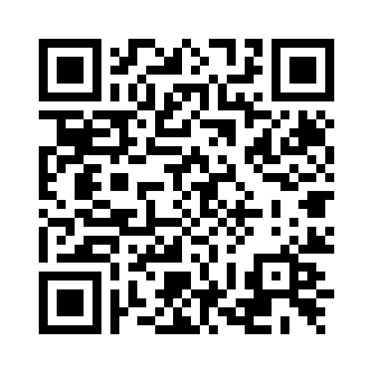

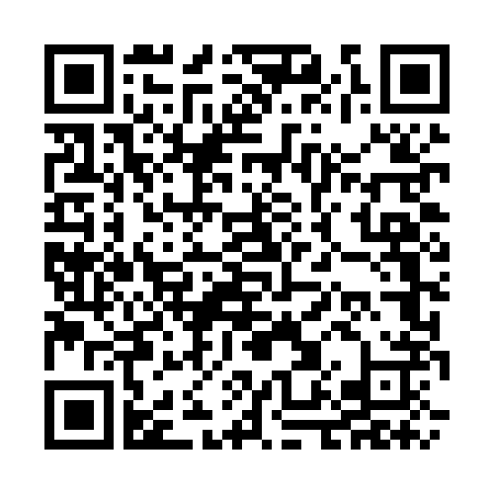
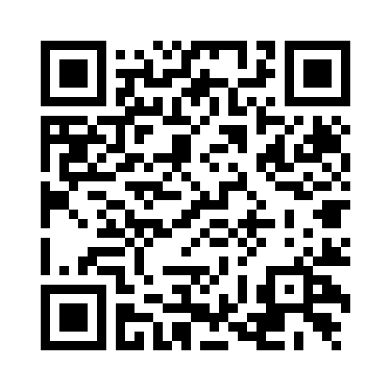

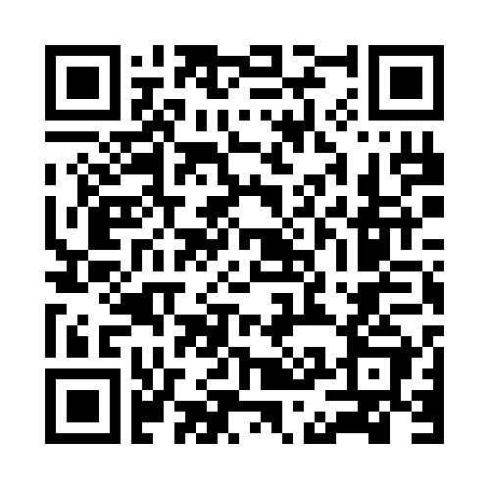
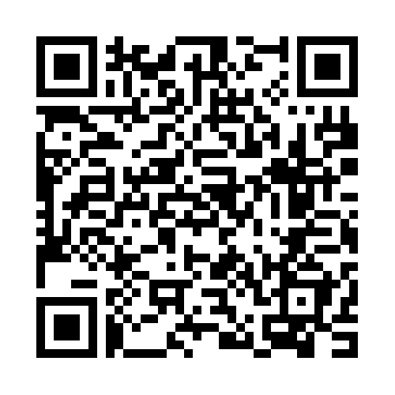
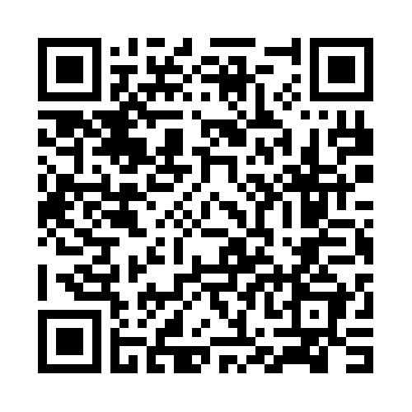
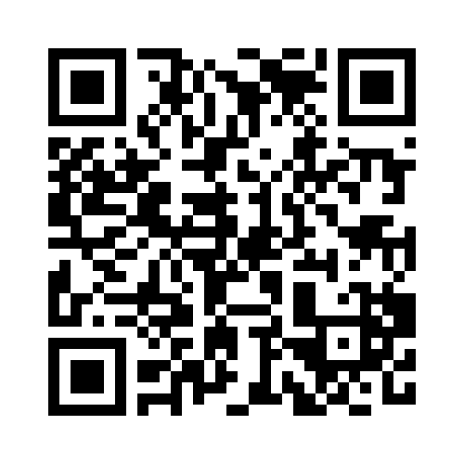
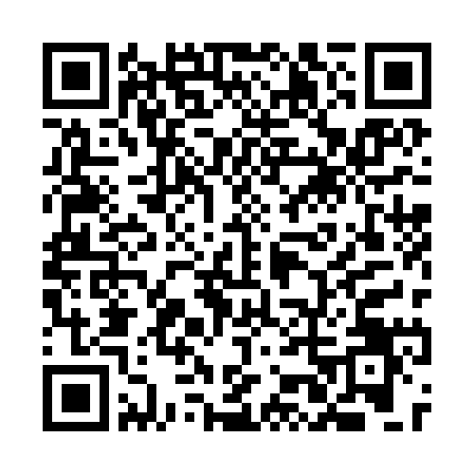

PHYSICS-ICT/ CULTURE

- Medium speed – (10 min) – test kahoot: https://create.kahoot.it/details/miscarea-rectilinie-si-uniforma/fd0bc13c-e00a-47bf-ac2a-d6b01d2497b0

- The speed of the vehicles - https://learningapps.org/display?v=p2vd344tj18

4) The speed of the vehicle drops- it breaks https://learningapps.org/display?v=papg5nx1318

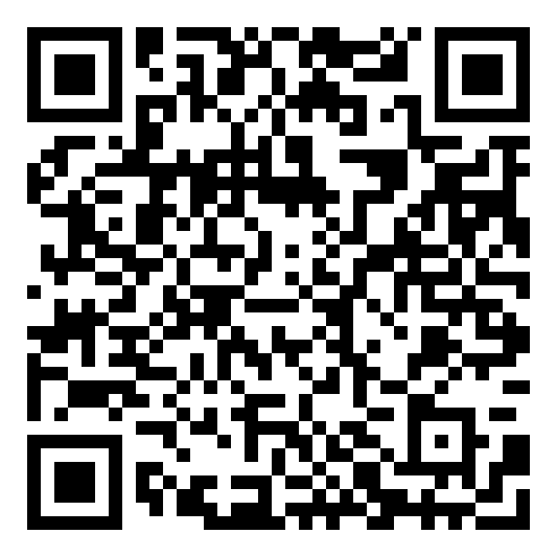

- PUZZLE -The principle of mutual actions http://www.jigsawplanet.com/?rc=play&pid=1064f791664e
- Puzzle -Pressure- http://www.jigsawplanet.com/?rc=play&pid=1f263296a028

- Educational online game– To be millionaire – site Learningapps: http://LearningApps.org/display?v=p16bsbbvk16
- Thermal phenomena- test kahoot
https://play.kahoot.it/#/k/3d9228bd-20de-4376-a43a-7b168288b304

- THERMAL ENGINES site LearningApps.org – QR code

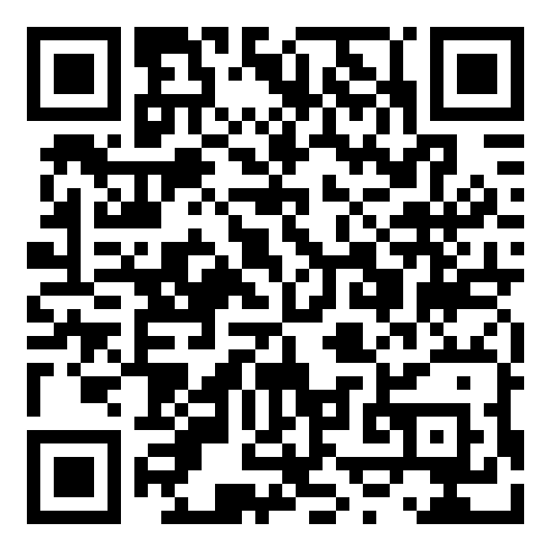

10) Feedback – test kahoot https://play.kahoot.it/#/k/26c6245a-fc88-497d-be51-16918e2d5e64
11)The lesson’s title site LearningApps.org – QR code

16) Digital skills – making digital games on LearningApps platform - https://learningapps.org/

17) TANGRAM PHYSICS-HISTORY

ENGLISH-ICT/ HISTORY/CULTURE
- https://docs.google.com/forms/d/1_ZE0a1bEfw_wTSEeZEcv__AI-4xGYmiyO6gga7rkrxQ/edit

- http://kahoot.eurodesk.eu

- https://create.kahoot.it/details/european-language-label/ab7acaf3-2a8d-452e-923a-fa07ee22a3b5

- https://create.kahoot.it/details/easter-traditions-in-romania/f45aeb2b-5f50-44f7-8eb3-639fb3a0f702

- https://create.kahoot.it/details/christmas-lesson/6d82b45f-b550-4221-8f23-3bf8033d7ba2

- https://create.kahoot.it/details/erasmus-lesson-1/05d1530e-4fce-4834-9f03-8de59bd57d31

- https://create.kahoot.it/details/erasmus-lesson-3/b15a27ed-89a4-492b-95f9-472174f1dff6

- https://create.kahoot.it/details/erasmus-lesson-2/d698ac87-d6f2-42d2-a2e3-989ccae6ccd0

PRIMARY EDUCATION
CIVICS EDUCATION
TRUST | BETRAYAL | MODEST | BOASTFUL
SINCERE | MOODY | GOOD | RUDE
SELFISH | GENEROUS | DISAGREE | 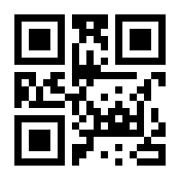  AGREE
FRIEND | ENEMY | COMMUNICATIVE | SILENT
QUARREL | UNDERSTANDING | TO HELP
LOVE | HATE | HELPFUL | IMPASSIVE
SOCIABLE | MEAN | REJECTION | ACCEPTANCE
QUIET | AGGRESIVE | RESPECT | CONTEMPT

This publication reflects the views only of the author, and the Commission cannot be held responsible for any use which may be made of the information contained therein.

