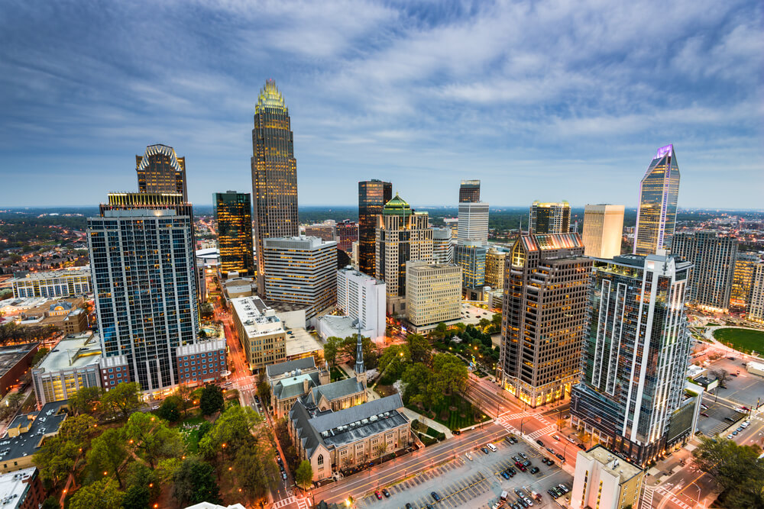
Baldwin Curtis Hunter Bolden Family Reunion 2020 Questionnaire
Name: ________________________________________________________________________
Address: ______________________________________________________________________
City: __________________________________________ State: _____ Zip: _________________
Phone Number: __________________________ Cell Phone: ____________________________
Email Address: _________________________________________________________________
[__] Sorry, we will not be able to attend the reunion.
[__] Yes, the following family members will be attending:
[__] Yes, the following family members will be attending Frankie’s Fun Park:

Name of Adults Name & Ages of children
__________________________________ _________________________________ ___________________________________ _________________________________
__________________________________ __________________________________
__________________________________ __________________________________

T-Shirts and Quantity (No additional t-shirts will be ordered)

____Small $ 6.50 _____Medium $6.50 _____Large $6.50
____ XLarge $7.50 _____ 2X $7.50 _____ 3X $7.50

Children T-shirt’s $6.50
X small (6-8) ____ Small (10-12) ____ Medium (14-16) ____ Large (18-20) ____ X large (22-24) ____

Mail: 3908 Medallion Drive, Charlotte, NC 28205
Email: baldwinfamilyreunion020@yahoo.com
Fax: 980-217-3200

